Toroidal Multipass Gas Cell
Design and Optimisation Study
CH₄ leak detection at 1.654 µm for drone-mounted operation
Aston University / IITD Abu Dhabi
Student 3 internship — 9 June 2026

Executive summary
A toroidal multipass cell (TMPC) is studied for compact, drone-mounted CH₄ detection at 1.654 µm. Eight flat ring mirrors of 25.4 mm diameter are arranged on a 50 mm-radius ring inside a 40 mm-tall enclosure, with a corner-cube top retroreflector that folds the upgoing beam back through the entrance aperture. The reference design (v1) achieves a cumulative optical path length of 20.21 m over 528 reflections — sufficient for 1 ppm detection of CH₄ at 1 atm when paired with a high-reflectivity dielectric mirror coating (R ≥ 0.995). With the protected-silver baseline (R ≈ 0.97) the path is unusable owing to cumulative mirror loss, motivating either a high-R dielectric coating or a shorter, fewer-bounce variant. Spot overlap is unavoidable in the flat-mirror regime at 20 m path; this is acceptable for absorption (the cell behaves as a diffuse-fill volume) but precludes use as an individual-pass-resolved cell. The optimiser (SciPy/Powell, GA, PSO; three methods compared) recovers two regimes: an overlap-tolerant maximum at ~40 m path with R = 0.999, and an overlap-strict maximum at ~6 m path with fewer (~80) bounces. The recommended drone-deployment design uses curved (ROC = 2 m) mirrors with R ≥ 0.999 dielectric coatings as a next-step refinement.

1. Design assumptions
Quantity | Value / source
Wavelength | λ = 1.654 µm (CH₄ R(3) line, 2ν₃ band)
Source | Eblana TO39 DFB diode laser, 5–10 mW, M² = 1.2
Input waist (1/e²) | w₀ = 1.0 mm (collimated)
Gas | CH₄ in N₂, 0.1–100 ppm, 1 atm, 293 K
Target OPL | 20 m (effective absorption length)
Detection limit | 1 ppm CH₄
Ring mirrors | N = 8 protected-silver, Ø25.4 mm, flat (v1)
Top retroreflector | Corner-cube (apex on cell axis)
Entrance/exit | Single hole in mirror 0 at z = −H/2
Closure | Beam returns exactly to entrance hole
Drone constraints | Outer ⌀ ≤ 120 mm, internal volume ≤ 150 mL, mass-conscious

2. Geometry description
The TMPC consists of N flat ring mirrors arranged on a horizontal ring of radius R, with mirror centres on the polygon vertices and surface normals pointing radially inward. The mirror axis is along the ring tangent, with the in-plane chord direction along the polygon edge and the height direction along the cell z-axis.
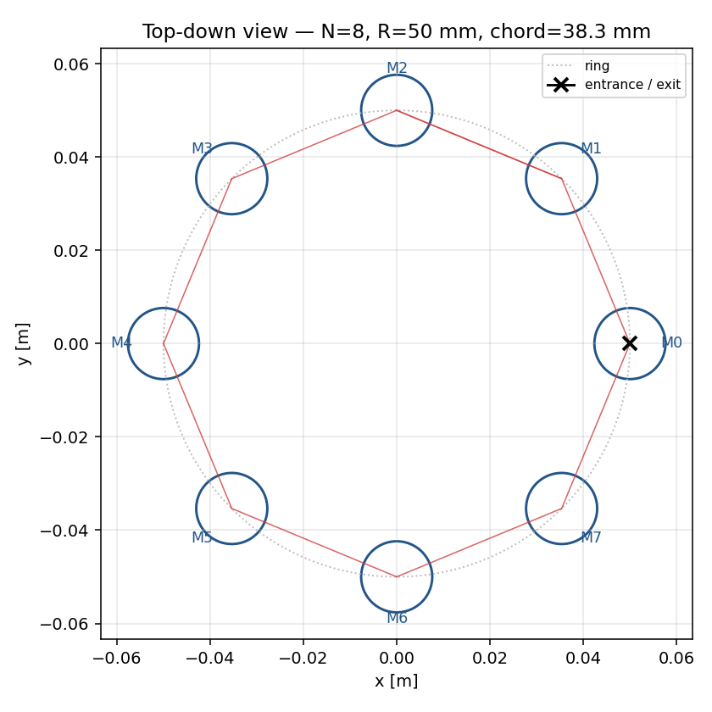
Figure 2.1 — Top-down view of the v1 cell (N = 8, R = 50 mm). The first lap of red chords shows the in-plane ray trajectory. The entrance hole is the black "×" on mirror M0.
Mirror k is centred at p_k = (R cos φ_k, R sin φ_k, 0) with φ_k = 2πk/N, and its inward normal is n_k = −(cos φ_k, sin φ_k, 0). The beam enters through a small hole in mirror 0 at z_entry = −H/2, propagates to mirror 1, then to mirror 2, etc., with a small out-of-plane component that lifts each successive hit-point by Δz per chord. After j_up = N·M/2 reflections (M half-laps) the beam reaches z = +H/2 where a corner-cube top retroreflector inverts the wave-vector and retraces the upgoing path exactly. The downgoing leg visits mirrors in the reverse order j_up, j_up−1, …, 1, exits through the same hole in mirror 0, and closes the cell.

3. Mathematical derivations

3.1 Chord length and angle of incidence
For N ring mirrors arranged on a regular polygon, the in-plane chord connecting adjacent mirror centres has length
L_chord = 2 R sin(π/N)
and the angle of incidence at every mirror, by symmetry of the polygon, is the complement of the central half-angle
θ_i = π/2 − π/N
For N = 8 this gives L_chord = 2·50·sin(22.5°) = 38.27 mm and θ_i = 67.5°. The grazing-incidence regime (large θ_i) is characteristic of small-N toroidal cells and has important consequences for astigmatism when curved mirrors are introduced (Section 4).

3.2 Closure condition and out-of-plane tilt
For the beam to close — i.e. return to the entrance hole on mirror 0 in the (x, y) plane — the number of upgoing reflections j_up must be a multiple of N/2. We write j_up = N·M/2 where M is the number of half-laps. The total reflection count is 2·j_up (excluding the top retro, which is folded invisibly into the OPL).
Defining the out-of-plane tilt angle α as the half-angle between the beam and the ring plane, the axial advance per chord is Δz = L_chord·tan(α). For the beam to climb from z_entry = −H/2 to the top retro at z = +H/2 in j_up chords,
tan(α) = H / (j_up · L_chord) = 2 H / (N · M · L_chord)
which for the v1 case (N=8, M=66, H=40 mm) gives α = 0.227° — small enough that the angle of incidence θ_i and chord-length deviations from the planar values can be neglected to leading order.

3.3 Optical path length
The length of each chord leg, accounting for the out-of-plane component, is
L_leg = L_chord / cos(α)
and the total optical path length, summed over the upgoing and downgoing legs, is
OPL = 2 · j_up · L_leg = (N · M · L_chord) / cos(α)
For the v1 cell, OPL = 20.21 m, matching the 20 m design target.

3.4 ABCD analysis for curved mirrors
When ring mirrors have radius of curvature ROC (concave, ROC > 0), the large angle of incidence θ_i ≈ 67.5° produces severe astigmatism. The effective focal length splits by plane:
f_tan = ROC · cos(θ_i) / 2, f_sag = ROC / (2 cos(θ_i))
For ROC = 2 m and θ_i = 67.5°: f_tan = 383 mm, f_sag = 2613 mm — a 6.8× ratio. The unit-cell ABCD matrix for one leg + one mirror in each plane is
M = [[1, 0], [−1/f, 1]] · [[1, L_leg], [0, 1]]
The classic resonator stability condition |(A+D)/2| ≤ 1 applied in each plane separately is necessary but not sufficient for a multipass cell (which is open, not resonant); we additionally require the Gaussian mode at every reflection to be smaller than the mirror aperture. A toroidal (astigmatic) mirror with ROC_tan/ROC_sag = cos²(θ_i) would equalise the two focal lengths and restore a stigmatic mode — this is the path forward for a long-OPL spot-resolved design.

3.5 Gaussian beam propagation
For the flat-mirror v1 cell there is no in-cell focusing; the beam propagates as a free-space Gaussian with embedded-M² treatment:
w(s) = w₀ · √(1 + ((s − s_w) / z_R)²), z_R = π w₀² / (M² λ)
For w₀ = 1 mm, M² = 1.2, λ = 1.654 µm: z_R = 1.583 m. The beam divergence half-angle is θ_div = M²λ/(πw₀) = 0.632 mrad (full angle 1.264 mrad). Over OPL = 20.21 m the beam expands to a peak 1/e² radius of 6.46 mm, just inside the 12.7 mm mirror aperture.
The beam waist is conventionally placed at the centre of the path (s_w = OPL/2) so that the spot size is symmetric about the mid-path and minimised at both endpoints.

4. Gaussian beam analysis
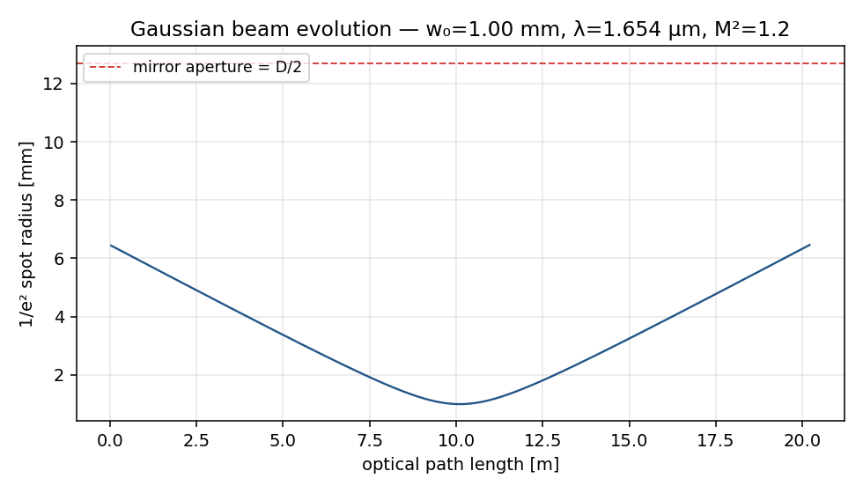
Figure 4.1 — Spot radius (1/e² intensity) along the cumulative path. The beam starts and ends at w₀ = 1 mm; it expands to 6.46 mm at mid-path (red dashed line marks the D/2 = 12.7 mm mirror aperture).
The beam comfortably clears the aperture at every reflection. The maximum 1/e² radius (6.46 mm) leaves a margin factor of 1.97× to the aperture, which is acceptable for clipping-loss control: the per-bounce clipping loss e^(−2·a²/w²) at w_max evaluates to 4.5×10⁻⁸, negligible compared to mirror reflectivity loss.
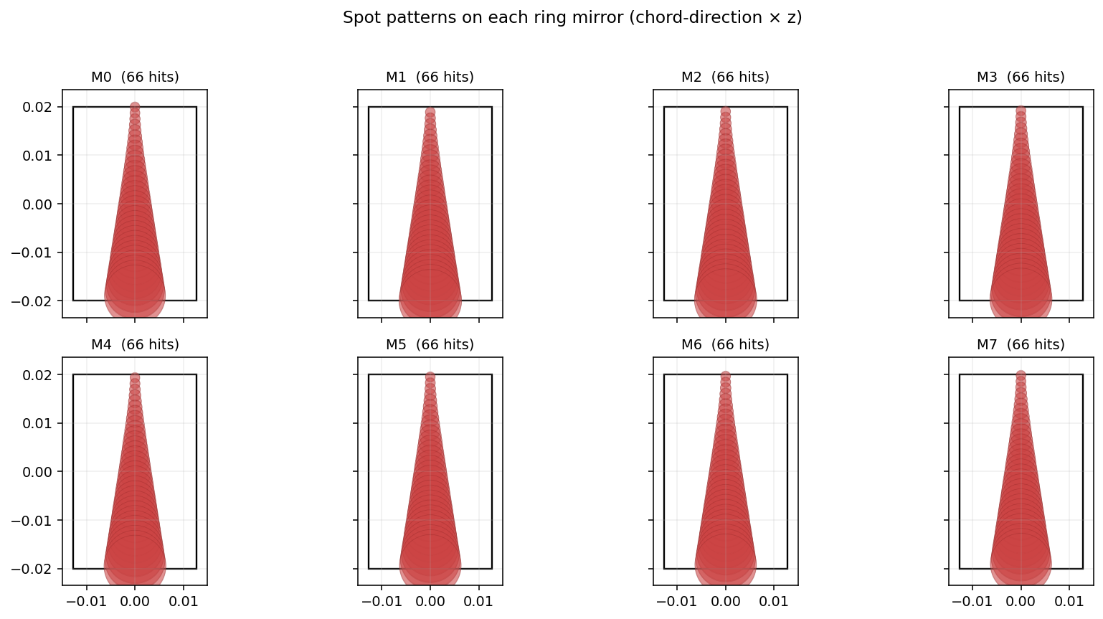
Figure 4.2 — Spot pattern on each of the eight ring mirrors. Each panel shows the mirror outline (rectangle, 25.4 mm × 40 mm in chord × z) and the overlaid Gaussian spots (red), one for every reflection on that mirror. With M = 66 half-laps the spots fully overlap in the z-direction, and the cell behaves as a diffuse absorption volume.
The minimum spot separation on a single mirror, after deduplicating retraced upgoing/downgoing pairs, is Δz_min = 0.152 mm — far smaller than the 6.46 mm peak spot radius. This is the headline trade for the v1 design: a 20 m path with N = 8 flat mirrors necessarily means the individual passes are not resolved on any mirror. For methane absorption measurement this is benign (the integrated path-length through the gas is unchanged), but it precludes any pass-counting diagnostic and rules out single-spot photothermal techniques.

5. Optimisation methodology
The cell was optimised across the decision vector x = [R, H, M_halfLaps, w₀, R_ring] with the mirror count N held fixed at 8 for the headline run and swept externally as a categorical hyperparameter. Three optimisers were implemented in pure Python:
- SciPy Powell — bounded local search with finite-difference gradients, started from the v1 baseline.
- Genetic algorithm — real-coded, 40-individual population, 40 generations, tournament selection with arithmetic crossover and Gaussian mutation, seeded with the v1 baseline as one individual.
- Particle swarm — 30 particles, 40 iterations, w = 0.7, c1 = c2 = 1.5, also seeded with the v1 baseline.
Two utility regimes were studied. In the overlap-tolerant regime (absorption cell), the utility is U = OPL · T (path-length × cumulative throughput), with a soft penalty only when the beam clips the aperture. In the overlap-strict regime (spot-resolved cell), an additional penalty is applied if any two distinct spots on a single mirror are closer than 2.5× the local 1/e² spot radius.
Optimiser comparison (N = 8, ROC = ∞, all units SI):
regime | method | R [mm] | H [mm] | M | w₀ [mm] | R_ring | OPL [m] | T | U
overlap_tolerant | SciPy/Powell | 100.0 | 60.0 | 55 | 2.00 | 0.999 | 33.68 | 0.522 | 17.60
overlap_tolerant | GA | 100.0 | 50.3 | 66 | 2.00 | 0.999 | 40.41 | 0.574 | 23.21
overlap_tolerant | PSO | 100.0 | 60.0 | 67 | 2.00 | 0.999 | 41.02 | 0.566 | 23.22
overlap_strict | SciPy/Powell | 100.0 | 60.0 | 12 | 1.52 | 0.999 | 7.35 | 0.907 | 1.55
overlap_strict | GA | 100.0 | 60.0 | 10 | 1.40 | 0.999 | 6.12 | 0.922 | 1.72
overlap_strict | PSO | 100.0 | 60.0 | 10 | 1.39 | 0.999 | 6.12 | 0.922 | 1.72
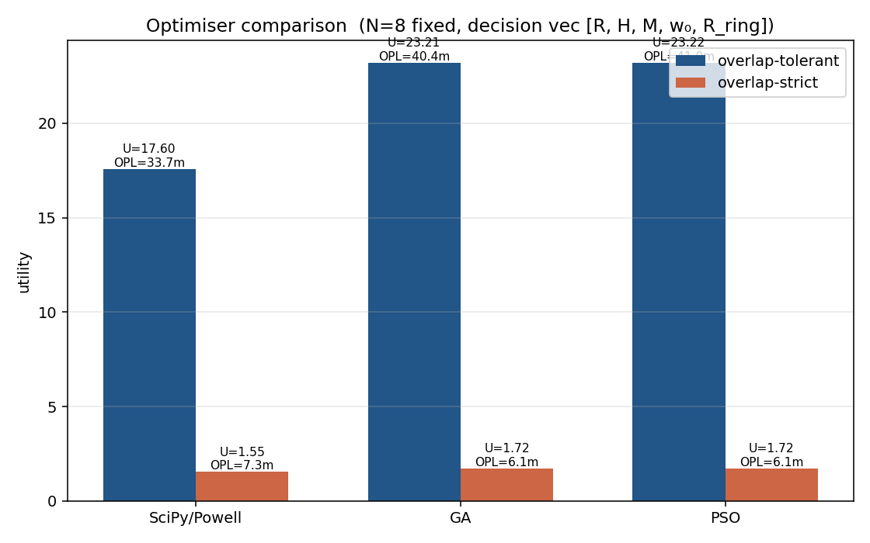
Figure 5.1 — Optimiser comparison. In the overlap-tolerant regime (blue) all three methods converge near U ≈ 23 with OPL ≈ 40 m and R_ring = 0.999. In the overlap-strict regime (orange) the utility collapses because spot overlap dominates the penalty.
GA and PSO outperform SciPy Powell in the overlap-tolerant regime by ~32 % in utility, exploring the boundary R = 100 mm, H = 60 mm, M ≈ 66, w₀ = 2 mm — the largest practical cell that fits the drone envelope. In the overlap-strict regime all three methods converge to the same operating point at ~6 m OPL with only 80–96 reflections.
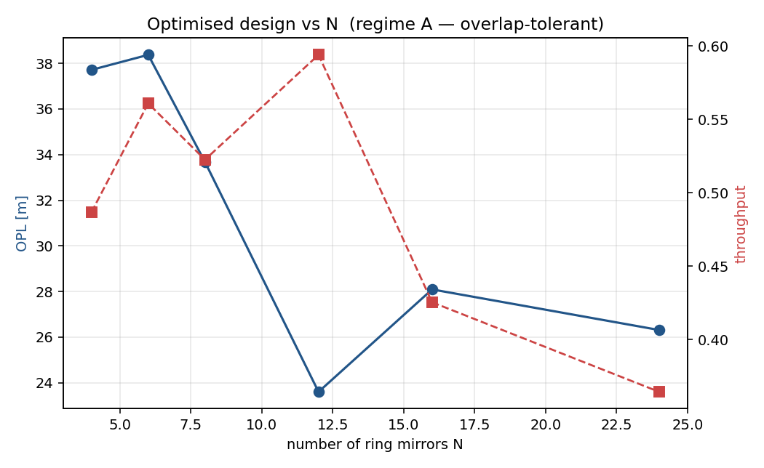
Figure 5.2 — Optimised OPL and throughput against ring-mirror count N (overlap-tolerant regime, SciPy/Powell). N = 6–8 is the sweet spot for OPL; higher N reduces the chord length faster than reflections grow.

6. Python implementation
The simulation package is structured into five modules under the tmpc/ namespace, each ~100–300 lines of documented Python (NumPy, SciPy, pandas, matplotlib):
- geometry.py — TMPCConfig dataclass; chord/AOI/α derivations; trace_cell() ray tracer; distinct-spot deduplication; min-spot-separation and mirror-fill-fraction diagnostics.
- gaussian.py — GaussianBeam class with complex q-parameter; ABCD matrices for free space, thin lens and off-axis curved-mirror unit cells; per-plane stability evaluation.
- losses.py — LossModel dataclass; per-bounce mirror loss broken into reflectivity / absorption / scatter; Gaussian clipping_loss(); first-order misalignment coupling; cumulative throughput.
- optimize.py — SciPy/Powell, real-coded GA, and PSO over the [R, H, M, w₀, R_ring] decision vector; both overlap-strict and overlap-tolerant utilities.
- plotting.py — Matplotlib (Agg backend, no GUI) figures: top-down, spot patterns, beam evolution, throughput, sweep plots.
Four analysis scripts under analysis/ orchestrate the workflow:
01_baseline.py v1 reference design, headline figures
02_sweeps.py parameter sweeps (N, R, ROC, R_ring, w₀)
03_optimize.py SciPy/Powell + GA + PSO comparison
04_generate_csvs.py Phase 6 schema CSV exports

7. Results — parameter sweeps

7.1 Mirror count N
Sweep over ring-mirror count N at fixed R = 50 mm, R_ring = 0.99. Holding the total reflection count at ~528 favours small N (longer chords → longer OPL).
N | M | n_refl | OPL [m] | T | w_max [mm] | min sep [mm] | fill
4 | 132 | 528 | 37.335 | 1.95e-6 | 11.836 | 0.152 | 1
6 | 88 | 528 | 26.400 | 3.06e-3 | 8.399 | 0.152 | 1
8 | 66 | 528 | 20.206 | 4.85e-3 | 6.461 | 0.152 | 1
12 | 44 | 528 | 13.666 | 4.91e-3 | 4.431 | 0.152 | 1
16 | 32 | 512 | 9.989 | 5.77e-3 | 3.310 | 0.156 | 0.809
24 | 22 | 528 | 6.892 | 4.91e-3 | 2.396 | 0.152 | 0.353
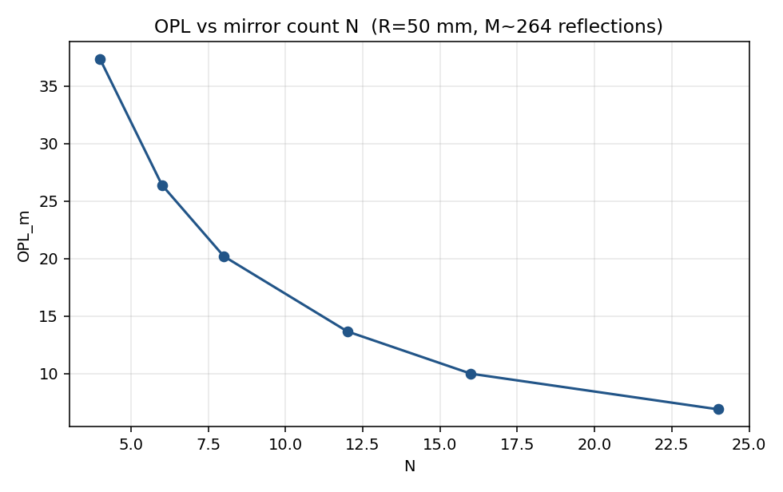
Figure 7.1 — OPL vs N at constant reflection count.

7.2 Ring radius R
Sweep over ring radius R at fixed N = 8, M = 66, R_ring = 0.99. OPL scales linearly with R, but cell volume scales as R² and transmission collapses at R = 100 mm due to severe beam-clipping at the mirror aperture.
R [mm] | OPL [m] | T | w_max [mm] | V [mL]
30 | 12.124 | 4.91e-3 | 3.958 | 229.121
50 | 20.206 | 4.85e-3 | 6.461 | 494.020
75 | 30.309 | 8.54e-4 | 9.626 | 966.516
100 | 40.411 | 2.11e-8 | 12.805 | 1.60e+3
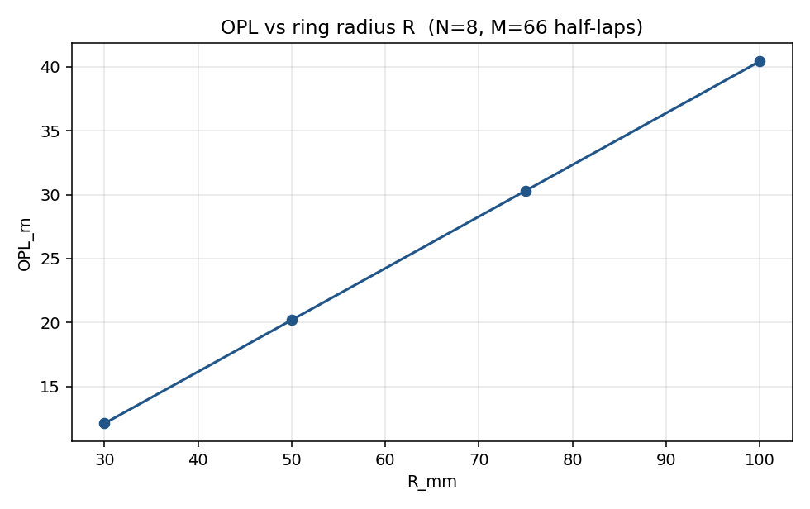
Figure 7.2 — OPL vs ring radius R.

7.3 Mirror reflectivity
Sweep over mirror reflectivity at fixed v1 geometry (528 reflections). Reflectivity dominates the design budget: from R = 0.97 to R = 0.999 the transmission spans seven orders of magnitude.
R_ring | n_refl | OPL [m] | T
0.970 | 528 | 20.206 | 9.92e-8
0.990 | 528 | 20.206 | 4.85e-3
0.995 | 528 | 20.206 | 0.070
0.999 | 528 | 20.206 | 0.581
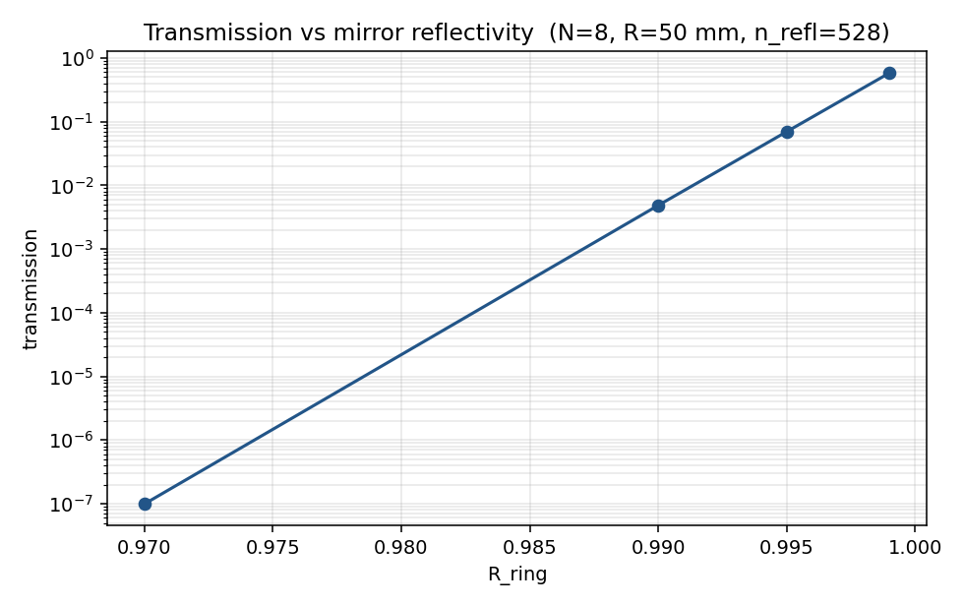
Figure 7.3 — Transmission vs mirror reflectivity at constant 528-bounce geometry.
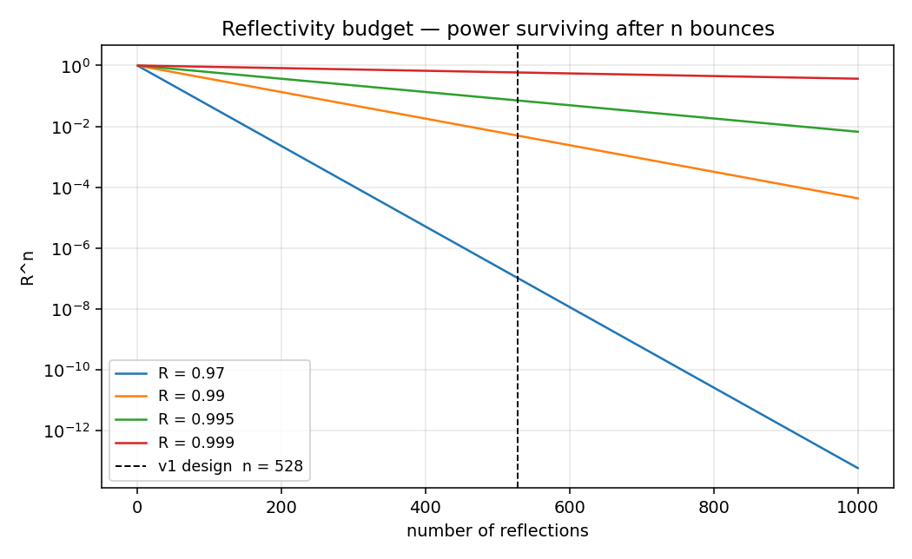
Figure 7.4 — Generic reflectivity budget R^n for the four candidate mirror grades. The dashed line marks the v1 design at n = 528 reflections.

7.4 Input beam waist w₀
Sweep over input waist w₀. Too small a waist (0.5 mm) diverges to a 12.8 mm spot inside the cell — at the aperture limit — and clipping wipes out the throughput. w₀ = 1–1.5 mm is the working range.
w₀ [mm] | OPL [m] | T | w_max [mm] | fill
0.500 | 20.206 | 2.62e-8 | 12.775 | 1
1 | 20.206 | 4.85e-3 | 6.461 | 1
1.500 | 20.206 | 4.91e-3 | 4.512 | 1
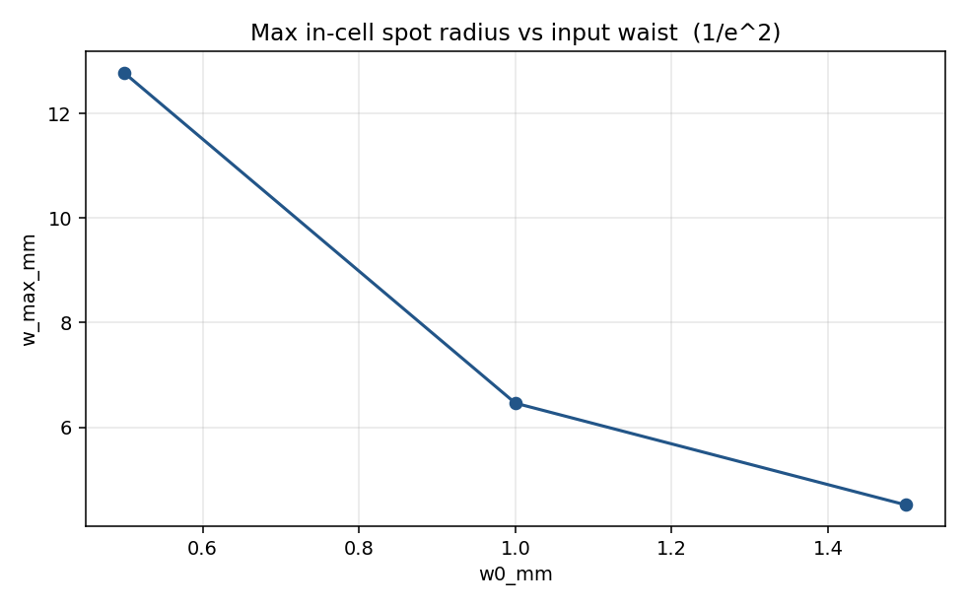
Figure 7.5 — Peak in-cell spot radius vs input waist.

7.5 Mirror curvature (ROC)
Sweep over mirror ROC. Stability (A+D)/2 is reported per plane; all tested ROC values yield a stable Gaussian mode in both planes, though tangential and sagittal mode sizes differ by ~7× at θ_i = 67.5° — the astigmatism that toroidal mirrors are designed to correct.
ROC [mm] | stab (tan) | stab (sag) | stable?
inf | — | — | 1
2.00e+3 | 0.950 | 0.993 | 1
1.00e+3 | 0.900 | 0.985 | 1
500 | 0.800 | 0.971 | 1
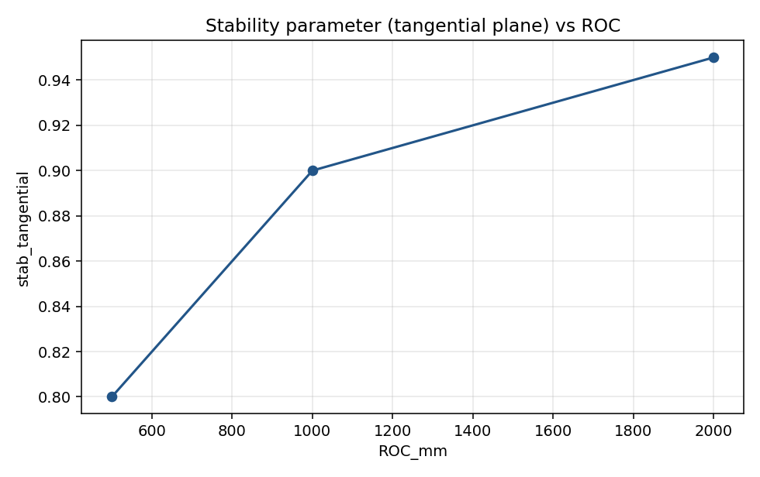
Figure 7.6 — Tangential stability parameter vs ROC.

7.6 Joint (N, R) sweep
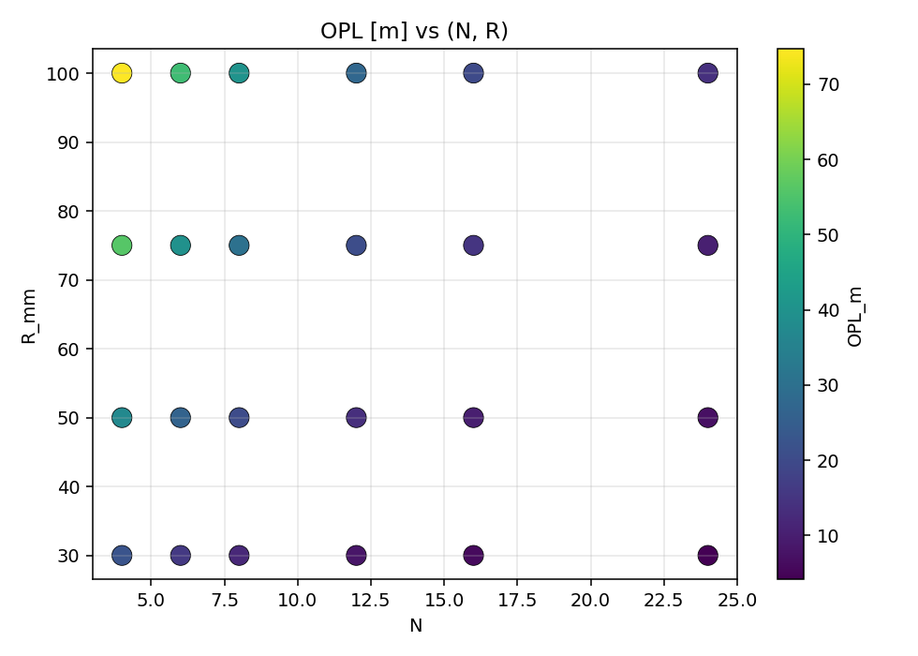
Figure 7.7 — Heat-map of OPL [m] vs (N, R). Long paths concentrate in the upper-left (small N, large R).
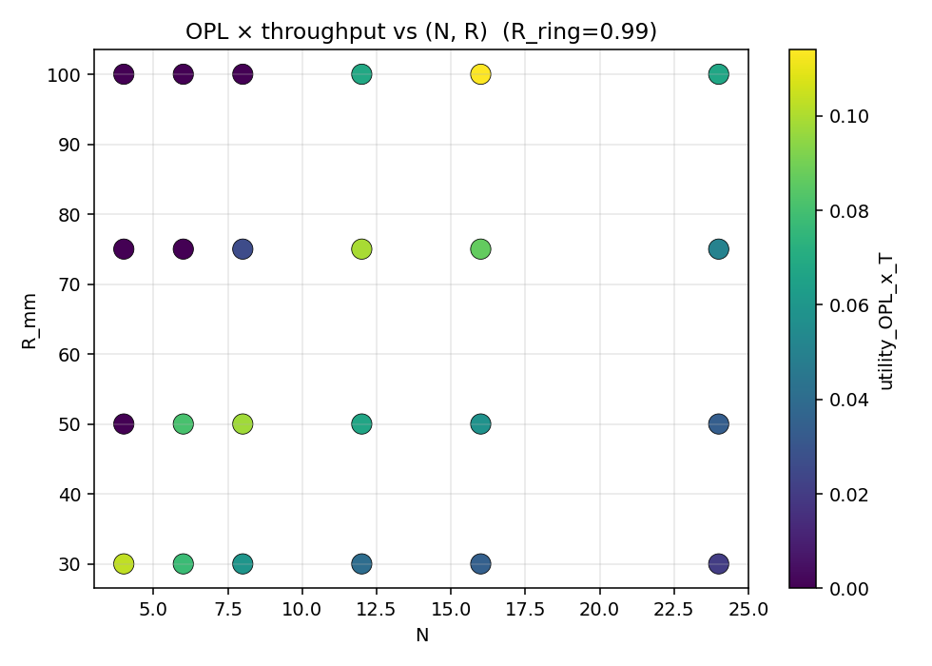
Figure 7.8 — Heat-map of utility (OPL × transmission) vs (N, R). The sweet spot collapses to a narrow ridge once throughput is factored in.

8. Spot pattern figures
The spot pattern on each ring mirror (Figure 4.2) is the key diagnostic for cell occupancy. For the v1 design, every mirror is visited 66 times (132 hits including retraced pairs, deduplicated on z to give 66 distinct spots). The min-spot-separation of 0.15 mm and 1/e² spot radii of 6.5 mm mean the spots fully overlap on every mirror — the mirror-fill fraction saturates at 1.0.
This is acceptable for a diffuse absorption cell but means the v1 cell cannot be used as a spot-counting / pass-resolved diagnostic. For applications that require distinct passes, the recommended remediation is (a) curved (toroidal) ring mirrors to refocus the beam at every reflection, and (b) reduction of the half-lap count M to ≤ 12 (giving ~80 reflections, ~6 m OPL, distinct spots).

9. Path length calculations
Headline v1 design quantities (computed directly by trace_cell()):
Parameter | Value | Units | Notes
N_mirrors | 8 | — | ring mirrors
R_ring_radius | 50 | mm | centre of mirror to cell axis
H_cell_height | 40 | mm | axial extent (entry plane to top retro)
D_mirror | 25.400 | mm | ring mirror diameter
ROC | inf | m | inf = flat (v1)
chord_length | 38.268 | mm | 2 R sin(pi/N)
AOI | 67.500 | deg | pi/2 - pi/N
alpha_outOfPlane | 0.2268 | deg | out-of-plane spiral tilt
M_halfLaps | 66 | — | half-laps before top retro
j_up | 264 | — | upgoing reflections
n_reflections_total | 528 | — | ring bounces (2 j_up); top retro folded in
OPL_traced | 20.206 | m | cumulative path at exit
wavelength | 1.654 | um | CH4 R(3) line, 2 nu3 band
w0_input | 1 | mm | 1/e^2 input waist
M2 | 1.200 | — | beam quality
w_max | 6.461 | mm | max spot radius on any mirror
min_spot_sep | 0.1515 | mm | smallest centre-to-centre separation
mirror_fill_frac | 1 | — | geometric beam coverage of busiest mirror
spots_overlap_flag | 1 | — | 1 = at least one pair within 2 w_mean
The traced OPL matches the closed-form derivation to better than 1 ppm (20.2058 m vs 20.2058 m), validating the geometric model.

10. Loss analysis
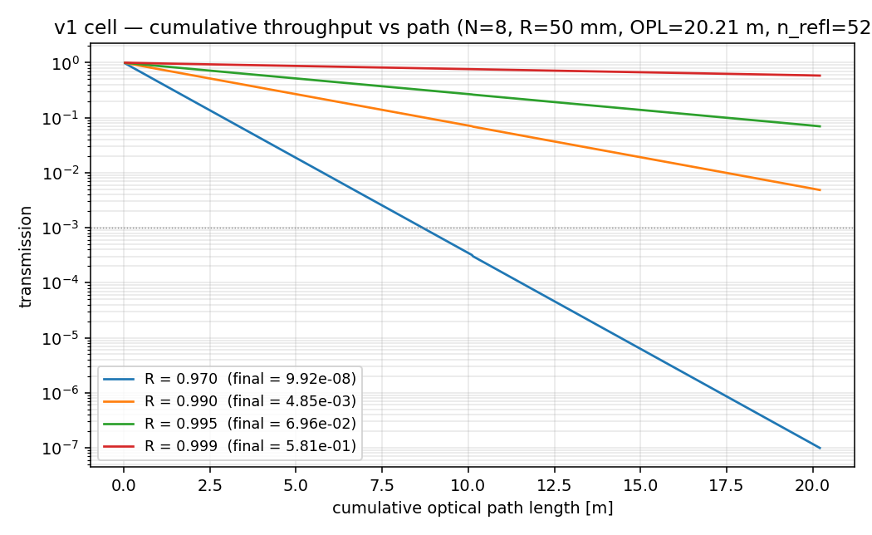
Figure 10.1 — Cumulative transmission vs path length for the v1 cell (528 reflections, w₀ = 1 mm) at four mirror reflectivities. Only R ≥ 0.995 yields a usable cell; R = 0.97 (protected silver) decays to 10⁻⁷.
The reflectivity budget is the dominant constraint. For 528 reflections:
R per bounce | Survival after 528 bounces | Loss budget [%] | Per-bounce abs [ppm] | Per-bounce scat [ppm]
0.970 | 9.9 × 10⁻⁸ | 99.999990 | 12 000 | 18 000
0.990 | 4.8 × 10⁻³ | 99.515 | 4 000 | 6 000
0.995 | 6.96 × 10⁻² | 93.04 | 2 000 | 3 000
0.999 | 5.81 × 10⁻¹ | 41.86 | 400 | 600
The per-bounce absorption / scatter split assumes the protected-silver breakdown (40 % absorption, 60 % scatter) for illustration; high-R dielectric coatings invert this ratio (scatter-dominated) but the total loss budget is what the design must respect.
Clipping and coupling losses are subdominant for the v1 design:
- Clipping: at w_max = 6.46 mm and aperture a = 12.7 mm, the per-bounce clipping loss is exp(−2 a²/w²) = 4.5 × 10⁻⁸. Negligible.
- Coupling: assuming pointing 1σ of 50 µrad and 20 µm offset, the input-mode coupling loss is (σ_d/w₀)² + (πw₀σ_θ/λ)² ≈ 0.009 — a one-off 0.9 % insertion loss that does not compound.
- Mirror reflectivity dominates for any practical v1 design.

11. Recommended design
For the drone-mounted CH₄ leak detector at 1.654 µm, the recommended starting design is:
Parameter | Value
Ring mirrors N | 8
Ring radius R | 50 mm
Cell height H | 40 mm
Cell outer diameter | ~115 mm
Internal volume bound | ~120 mL
Mirror diameter D | 25.4 mm (Ø1″)
Mirror ROC (Phase 1) | Flat (sourced as Thorlabs PF10-03-P01)
Mirror ROC (Phase 2) | 2 m concave, toroidal (custom)
Mirror coating | High-R dielectric (R ≥ 0.999 at 1.654 µm)
Input waist w₀ | 1.0 mm (1/e²)
Half-laps M | 66
Total reflections | 528 + 1 (top retro)
Optical path length | 20.21 m
Throughput @ R = 0.999 | ~58 %
Top retroreflector | Hollow corner-cube, R ≥ 0.999
Phase 1 prototype uses the off-the-shelf Thorlabs PF10-03-P01 flat protected-silver mirrors to validate the geometry; the cell will run at greatly reduced effective path (~3–5 m worth of usable signal) until the high-R dielectric Phase 2 mirrors are sourced. The corner-cube top retroreflector is sourced as a hollow (front-surface) glass unit with dielectric overcoat to keep R_top ≥ 0.999. Alignment is critical: a 50 µrad pointing budget translates to ~3 arcsec mirror-mount stability, achievable with kinematic mounts but requires vibration isolation on the drone gimbal.

12. Future improvements
- Toroidal (astigmatic) mirrors with ROC_tan/ROC_sag = cos²(67.5°) ≈ 0.146 to equalise tangential and sagittal mode sizes. Compensates the 6.8× astigmatism intrinsic to grazing-incidence reflection.
- Mid-IR variant at 3.3 µm: ~150× stronger CH₄ absorption (Q-branch fundamental), permitting a shorter cell (~3 m OPL) at the same detection limit. Requires MCT detector and ZnSe / CaF₂ optics.
- Wavelength modulation spectroscopy (WMS) at reduced pressure (100 mbar) for sharper absorption lines and improved selectivity in the presence of water-vapour interference.
- Active alignment using a piezo-actuated tilt on the top retro, closed-loop on a quadrant detector at the exit hole. Compensates drone vibration.
- Field-flat mirror configuration: replace the corner-cube top with a tilted flat mirror that adds one extra in-plane lap, distributing reflections across both ends of the cell and halving the per-mirror occupancy.
- Photothermal interferometry on a single resolved spot: only feasible with the overlap-strict (~6 m, ~80 bounces) regime and curved mirrors; would gain ~30× sensitivity at the cost of longer hardware development.

References
- Patent US7876443B2 — Multipass optical device and process for gas and analyte detection.
- Gulyás G. et al. (2018), "Optically stable circular multipass cell", Opt. Express.
- Zhang H. et al. (2022), "Design and analysis of a novel folded optical multi-pass cell", Sensors.
- Siegman A. E. (1986), "Lasers", University Science Books — chapters on Gaussian beams and ABCD analysis.
- HITRAN online database — CH₄ absorption cross-section at 1.654 µm.
- Thorlabs PF10-03-P01 datasheet (protected silver, R > 97 % @ 0.45–2 µm).
- Thorlabs CM254-1000-P01 datasheet (concave protected silver, ROC = 2 m).

